**CV Digital Day 2022 smart contract setup guide**

**Deploy**

To deploy the smart contract, run the following command in the terminal:

npm:

npm run deploy

yarn:

yarn deploy

You should see your terminal providing a link to deploy the contract through your browser:

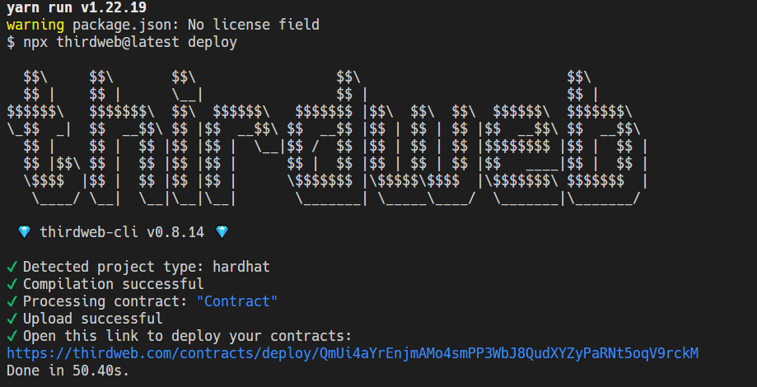

If your browser doesn't pop open automatically, paste the link provided on the terminal into your browser. Now, a page should be opened on your browser prompting you to deploy the contract:

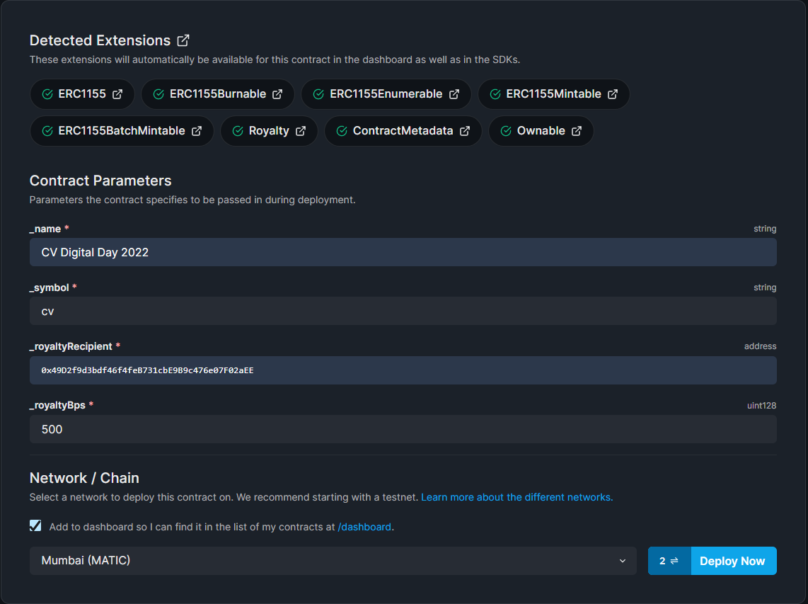

* _name: The name of our contract
* _symbol: The symbol or "ticker" given to our contracts tokens
* _royaltyRecipient: The wallet address that will receive the royalties from secondary sales
* _royaltyBps: The **basis points** (*bps*) that will be given to the royalty recipient for each secondary sale, e.g. 500 = 5%

Finally, select the network you want to deploy, and click "Deploy Now".

Once the deployment is complete, you should be redirected to your contract dashboard and you can see the contract explorer that lets you interact with various functions of your smart contract:

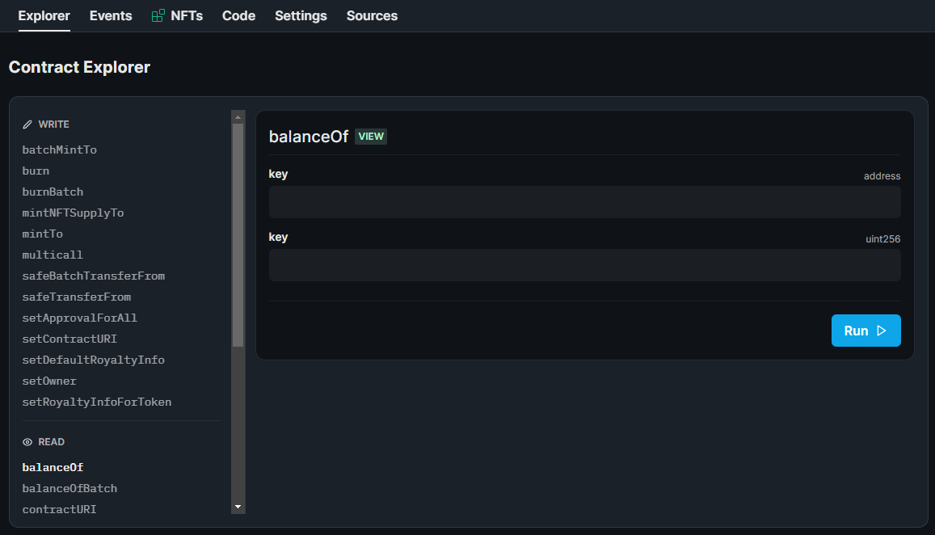

Please update the contract address in frontend env with new one.

**Minting**

The thirdweb SDK allows only owner can mint NFTs.

Minting NFT in the frontend don't mint a new token, instead it is only increasing the supply (amount) of selected token. So you need to mint all NFTs (first and second) with 0 supply, so the users can increase supply of it.

Now, let’s mint our NFTs.

*Important: The tokenId of First NFT should be 0 and the tokenId of Second NFT should be 1*

Go to NFTs tab and Click on the blue ‘+ Mint’ button in the top right corner.

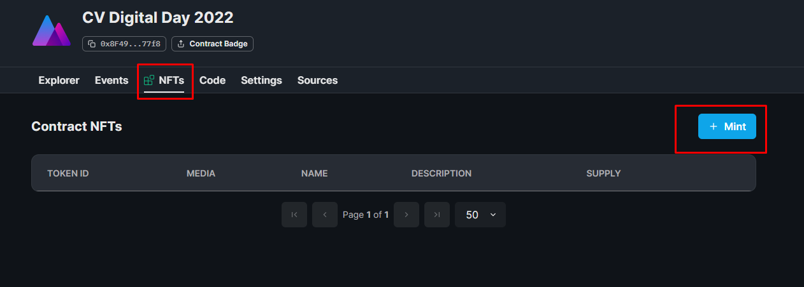

A settings panel will pop up on the right side of your screen. Give your NFT a name, description, and upload your file.

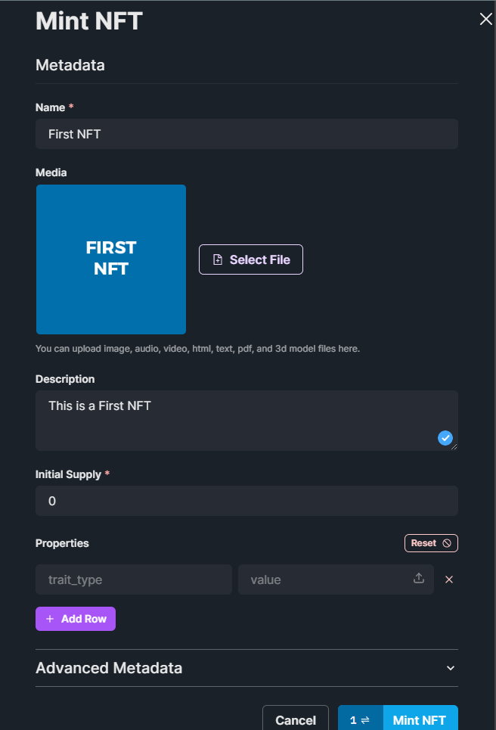

After adding the fields, click on the blue ‘Mint NFT’. You will be prompted to confirm the transaction in your wallet. Click the confirmation button. And that’s it- the newly minted NFT will appear in your dashboard.

Mint second NFT with same way.

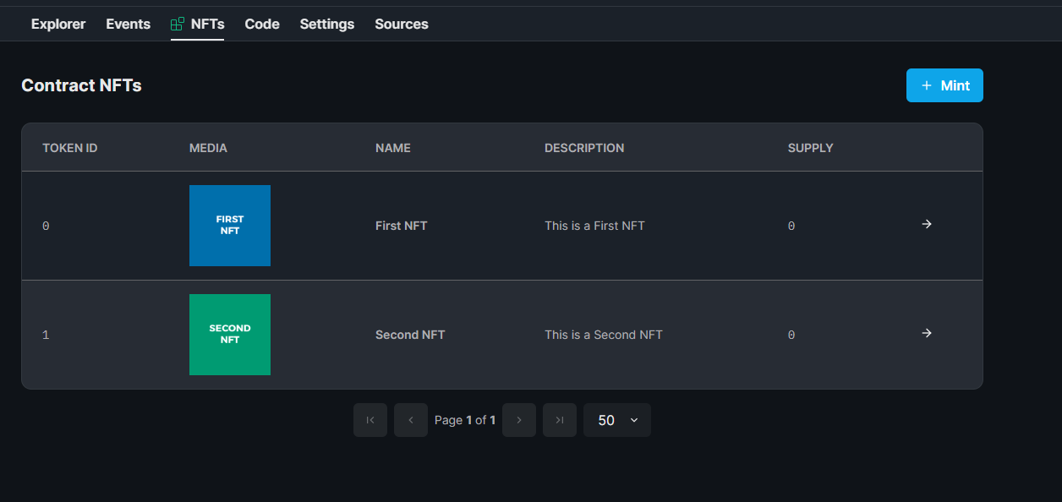

For third NFT, you can mint as many as you want. Anyone else can’t access it(mint/burn). Only you can mint/burn/transfer it.

I think you need to mint it with 1 initial supply according to current logic of our app.

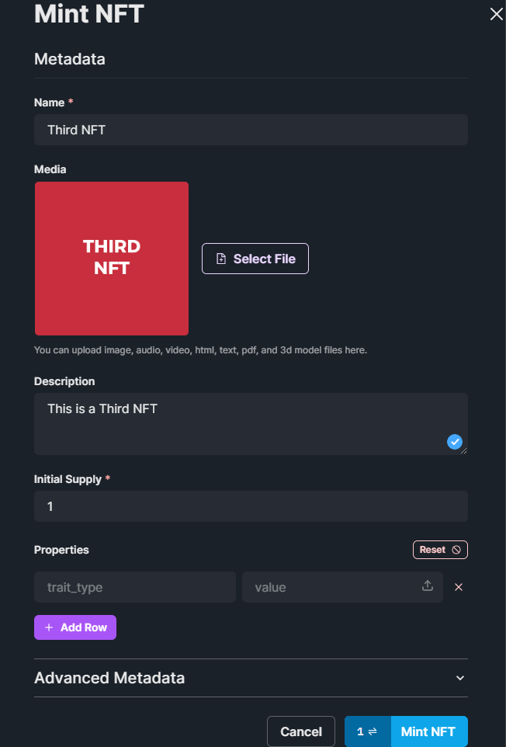

Done.

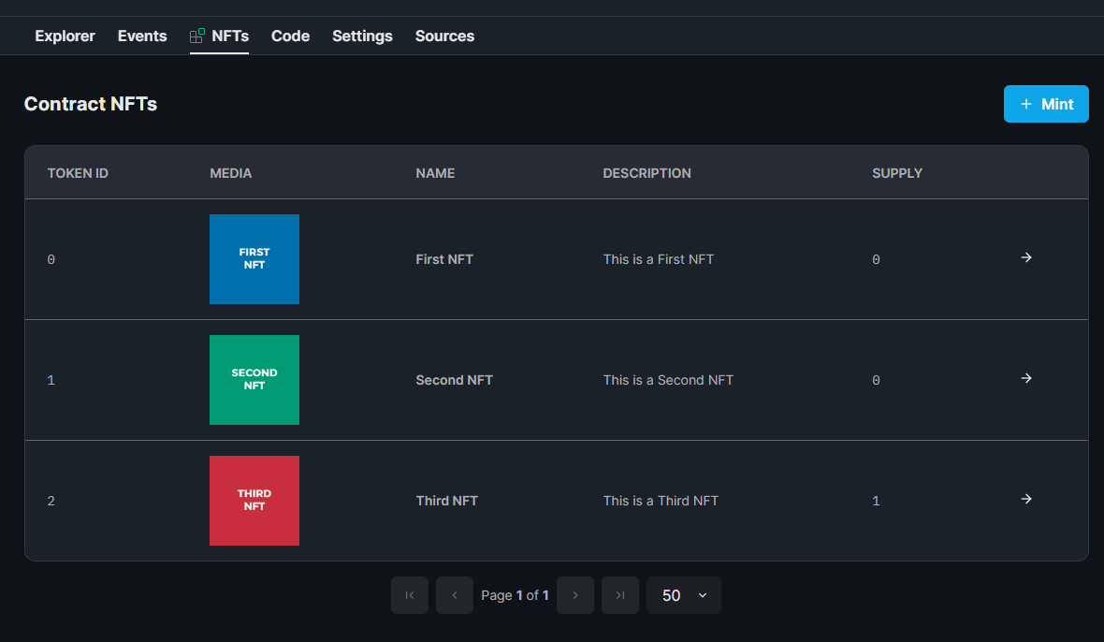

You can check everything on the thirdweb dashboard. And you can easily transfer third NFT to winner with safeTransferFrom function.

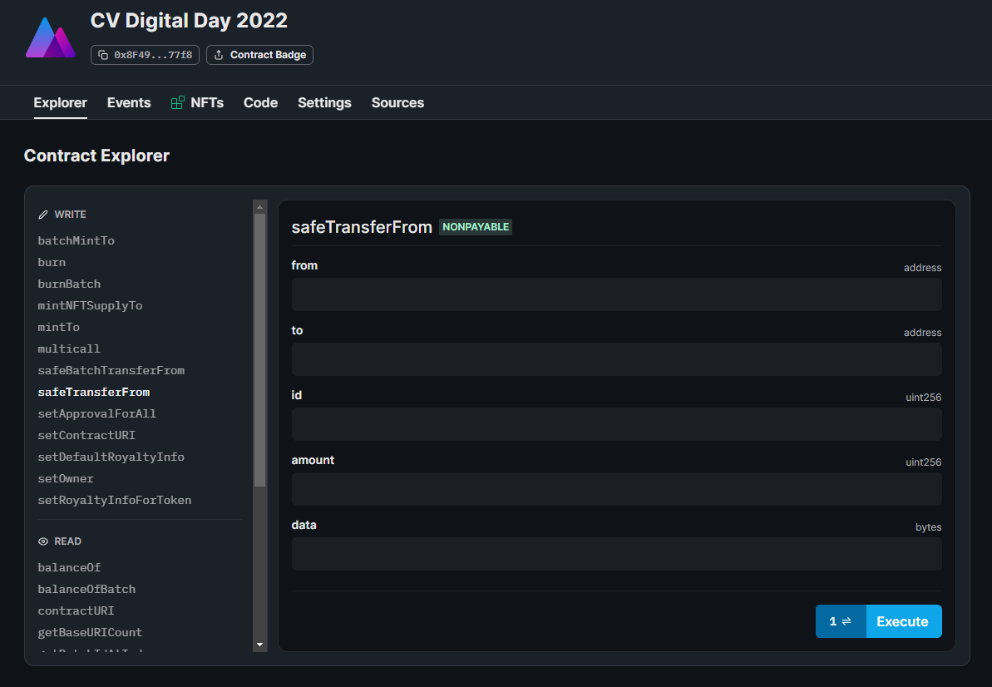

References:

<https://portal.thirdweb.com/getting-started/creating-custom-contracts#deploying>